

Subject: Computer Network Security Class: TE-IT

Date: 09/11/2022 Subject Incharge: Prof. Stella J

**CNS Oral/ Practical Exam Questions**

1. Write a python program to encrypt a plain text using ceaser cipher

#Ceaser Cipher Encryption

import string

all_letters= string.ascii_letters #A list containing all characters

dict1 = {}

key = 3

for i in range(len(all_letters)):

dict1[all_letters[i]] = all_letters[(i+key)%len(all_letters)]

plain_txt= "HARSH"

cipher_txt=[]

# loop to generate ciphertext

for char in plain_txt:

if char in all_letters:

temp = dict1[char]

cipher_txt.append(temp)

else:

temp =char

cipher_txt.append(temp)

cipher_txt= "".join(cipher_txt)

print("Cipher Text is: ",cipher_txt)

1. Write a program to encrypt the given text using Railfence technique

#Railfence Encryption

cipher_text=""

def railfence(plain_text,key):

if key==3:

return (plain_text[::2]+plain_text[1::2])

else:

return "number of rails not supported"

cipher_text= railfence("lol is fake ", 3)

print("Cipher Text Using Railfence:",cipher_text)

1. Write a program to decrypt the text “aLH” using ceaser cipher

#Ceaser Cipher Decryption

import string

all_letters= string.ascii_letters #A list containing all characters

dict1 = {}

key = 3

for i in range(len(all_letters)):

dict1[all_letters[i]] = all_letters[(i-key)%len(all_letters)]

cipher_txt= "KDUVK"

plain_txt= []

# loop to generate ciphertext

for char in cipher_txt:

if char in all_letters:

temp = dict1[char]

plain_txt.append(temp)

else:

temp =char

plain_txt.append(temp)

plain_txt= "".join(plain_txt)

print("Plain Text is: ",plain_txt)

1. Perform brute force attack on “aLH LV EHVW”

**(Note* Any encrypted text will be given)**

**#Brute Force Attack on Ceaser Cipher**

**import string**

**all_letters= string.ascii_letters #A list containing all characters**

**dict1 = {}**

**for key in range(0,25):**

**for i in range(len(all_letters)):**

**dict1[all_letters[i]] = all_letters[(i-key)%len(all_letters)]**

**shift_txt="KDUVK"**

**plain_txt= []**

**# loop to generate ciphertext**

**for char in shift_txt:**

**if char in all_letters:**

**temp = dict1[char]**

**plain_txt.append(temp)**

**else:**

**temp =char**

**plain_txt.append(temp)**

**plain_txt= "".join(plain_txt)**

**print("Plain Text is: ",plain_txt)**

1. Perform product cipher on the encrypted message “aLH LV EHVW” using railfence technique

**(Note* Any encrypted text will be given)**

**block3=product_text[:6:]**

**print(block3)**

**block4=product_text[6::]**

**print(block4)**

**print("Decrypted Product Text:",end="")**

**x1=print(block3[0]+block4[0]+block3[1]+block4[1]+block3[2]+block4[2]+block3[3]+block4[3]+**

**block3[4]+block4[4]+block3[5]+block4[5])**

1. Perform encryption and decrption of a Plain text message using Open SSL Commands
2. Perform RSA encryption and decryption
3. Find the person who performed password attack and modified text on your machine using network commands (exp - 6)

**(Note* Attack will be performed / may ask you perform and the content will be in encrypted form. You need to decrypt and view the message)\**

1. Analyze the http and https packet using wireshark in ubuntu

    

1. Analyze the ssh and ftp connection using wireshark in windows  
     
       
2. Analyze the open ports available in the network and make a report

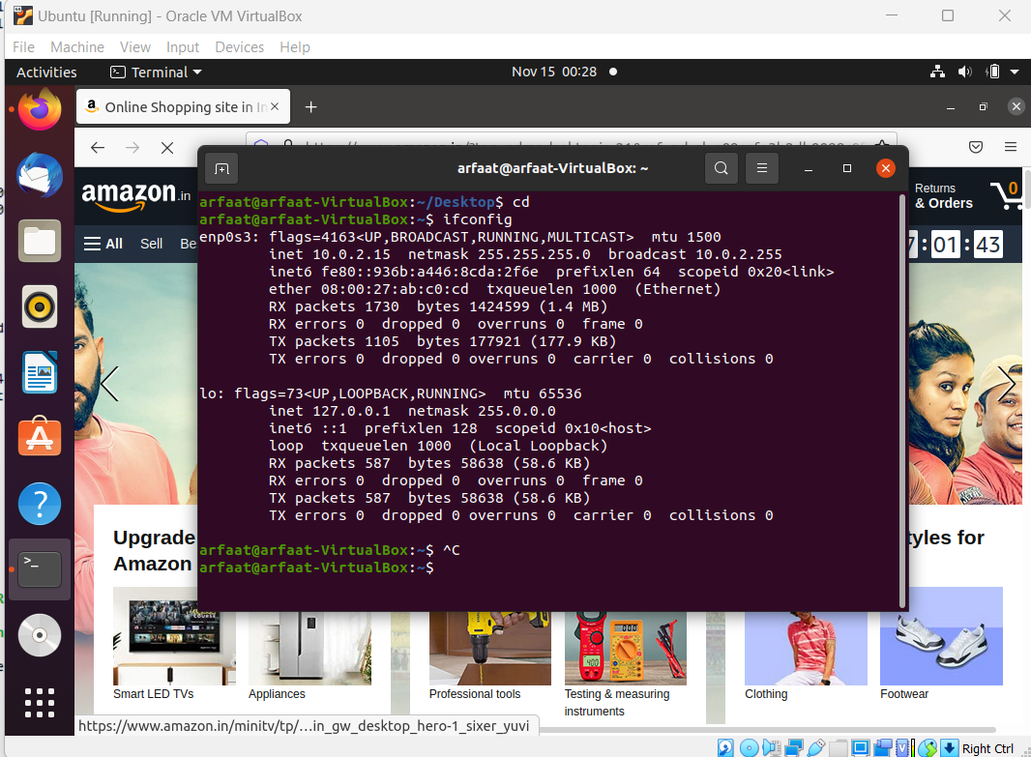 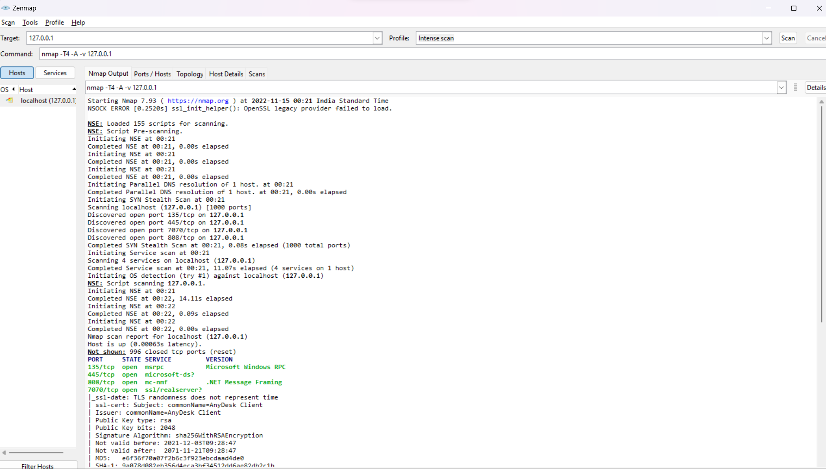 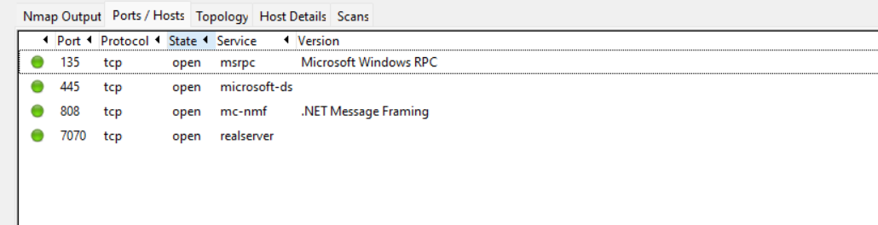 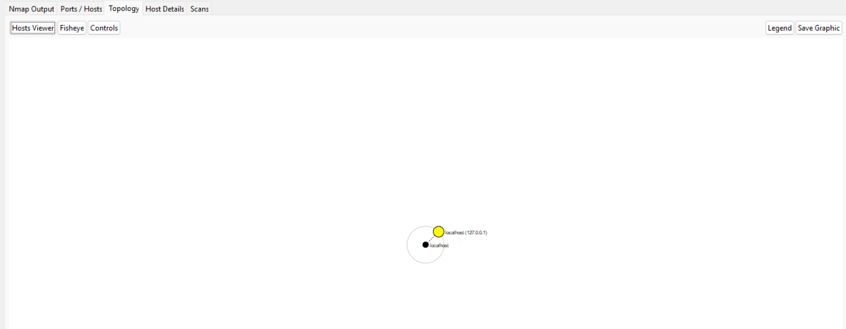 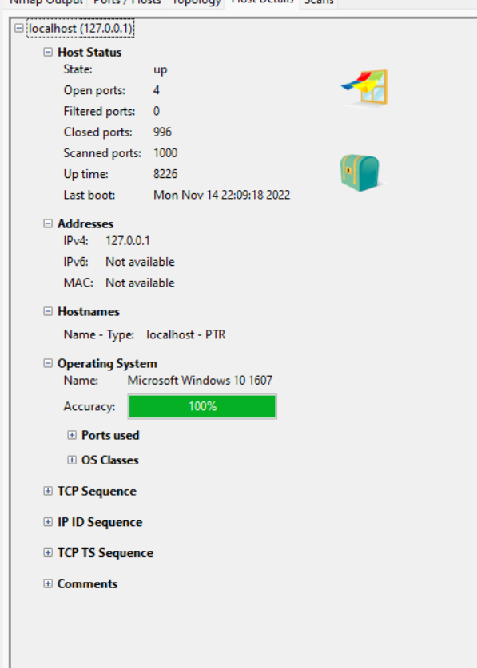 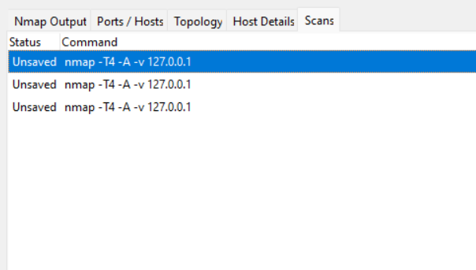

1. Perform encryption and decryption of email security in Kleopatra

**\*VIVA Questions will be asked from the syllabus**